The search for the new possibilities of growth in mushroom cropping
By Nikodem Sakson. Consultant. Poznan, Poland. http://www.nikodemsakson.pl/

When analysing mushroom cropping in the period of three flushes, we can observe a general decrease in cropping with every flush. Assuming that the average cropping of three flushes is on the level of 30kg/m² the mushroom cropping yield distribution is typically as follows: 15kg/m2 in the first flush, 10kg/m² in the second flush and 5kg/m² in the last flush. From the point of view of cultivation no changes have been made in the mushroom surroundings. We can always create the required microclimate, pick the mushrooms selectively and control losses caused by pests and diseases (mainly green moulds and dry bubble). There is live mycelium in the casing and on the surface, there sufficient number of compounds to achieve higher crop, however the crop is decreasing. Why?
Several causes can be indicated and actions undertaken, which can counteract the situation. An additional factor encouraging the search for cropping stability in all flushes are new products allowing for other ways to interact in the mushroom feeding process. Synthetic additives both liquid and solid with prolonged action time and additives that in the future will come from liquefying the compost or other natural resources could allow for a change in the current mushroom feeding model.
Why are we not achieving stable cropping in three consecutive flushes?
- The easily available nutrients may run short.
- The compost may be polluted with the metabolism waste from the cropping mushroom.
- There may be a change in the physical conditions, mainly in the compost structure whilst composting with the participation of mushrooms limiting the exchange of gases with the surroundings.
- Genetic reasons. Mushrooms can be ‘programmed’ in a way that they achieve most yield in the first two flushes. The solution would be to look for a new variety. The falling number and weight of growing fruiting bodies is a reaction to the worsening conditions of their vegetation. In this situation only by limiting the number of fruiting bodies can allow for spore production, which is the spore’s main goal.

What solutions should we look for that will ensure a balanced mushroom cropping in all three flushes?

The assumption that lies at the foundation of the options to choose from is that mushrooms for their cropping require a controlled feeding process which depends on:

- A permanent access to nutrients that are easily absorbed by the mushrooms in cooperation with microorganisms which generate the nutrients in the cold composting process in oxygen conditions (rotting, mineralisation) in the compost and casing.

In order to produce 1kg of fruiting bodies you need about 220g of dry compost and 900ml of water. Currently only 45% of the dry compost is used. The compost activity is a composting process indicator according to the polysaccharide decomposition process to obtain carbon dioxide, water and energy as the consecutive flush yield drops.

In the first flush the easily available nutrients in compost run short. If replenished, they should influence the cropping growth in the next flushes.

For the interference in the mushroom’s nutrients base to be effective it is worth considering other methods of evaluating the composts ability to feed the mushrooms effectively. This issue is a topic for a separate article.

- Permanent and uninterrupted transport of dissolved nutrients in water from the compost. It would be interesting to make a controller that would monitor the air movement, the compost activity and evaluate the mycelium and pins behaviour.

A proposed solution.

The aim would be to balance cropping to the level of 15kg/m² in each flush.

The first solution being tested is airing the compost whilst collecting the crops and maintaining the vegetative process in spite of the worsening structure (compost decay; the compost “drops”), water increase between the compost straws and the achievement of compost sanitisation from the metabolism by products. It has to be remembered that the compost utilisation reaches 50% at the most. The rest of the components are removed.

The next solution is to make a container with a liquid additive which would increase the level of easily available nutrients and microelements in the cropping process. The middle tray below demonstrates this.

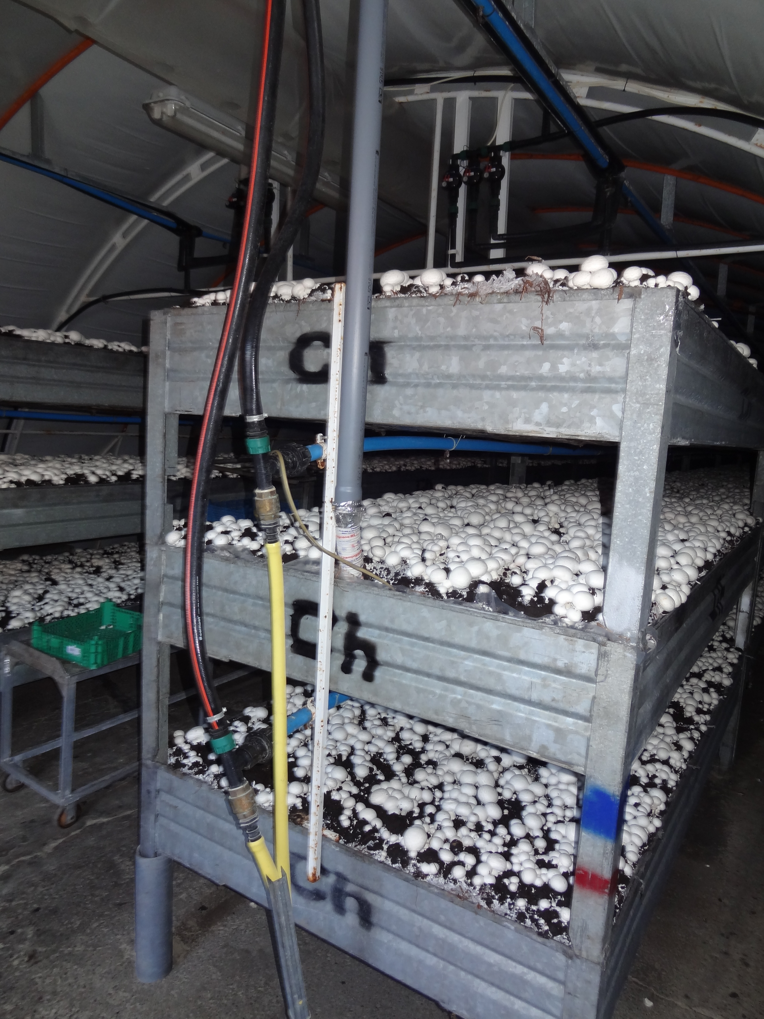

And the third solution, if the two first prove to be effective, is to combine the airing and working with the container filled with the nutrients. These solutions are currently subject to tests here in Poland.

If the trials are successful, a mushroom cultivation method can be developed basing on a low amount of most likely granulated compost, liquid feeding close to the hydroponic system of feeding plants where any ingredients can be replenished and also help with a possible clearing of mushroom metabolism waste products.

A separate topic is tying up and cropping. The modern technology creates a number of new possibilities, and it is a subject for a different article.

For further information please contact me Nikodem Sakson (n.sakson@wp.pl) or visit my website on http://www.nikodemsakson.pl. Also addition details about Mycronutrient and Liquid Gold can be found at www.nutrigain.com.

